

Electrical and Computer Engineering Department
University of Tehran
Digital System Design with Hardware Description Languages
Fall 1385
Homework 6
All problems require testbench and complete simulation

FIR Filter Hardware Implementation
In this problem you are to design and describe a filter processor. The filter has coefficients and data inputs. We assume coefficients and data inputs are in a dedicated section of the memory. The processor reads data from this memory and puts the resulting data into another section of the memory.
Filter coefficients are taken from the impulse response of a filter. These coefficients are the main factors in filter design. A generic hardware can be implemented using the structures that we discuss, and it can be configured for a specific filter by changing the coefficients.
Let us consider a 4th order FIR filter with five coefficients as shown below. The RTL design of this filter is discussed in the following paragraph.

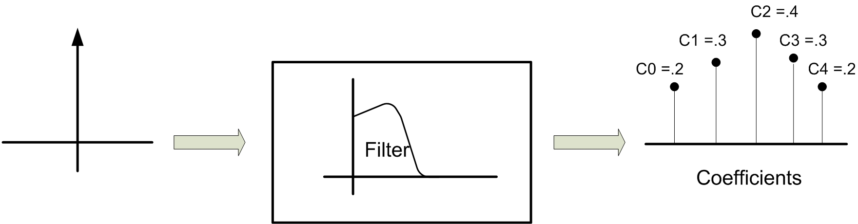

FIR Filter RTL Design. The block diagram of the RT level hardware of a fourth order FIR filter is shown below. A series of registers provide delayed inputs that are multiplied by c_{i} coefficients and then added together to generate the output. The clock frequency for the registers must the same as the sampling frequency that is twice the largest frequency of the input signal.

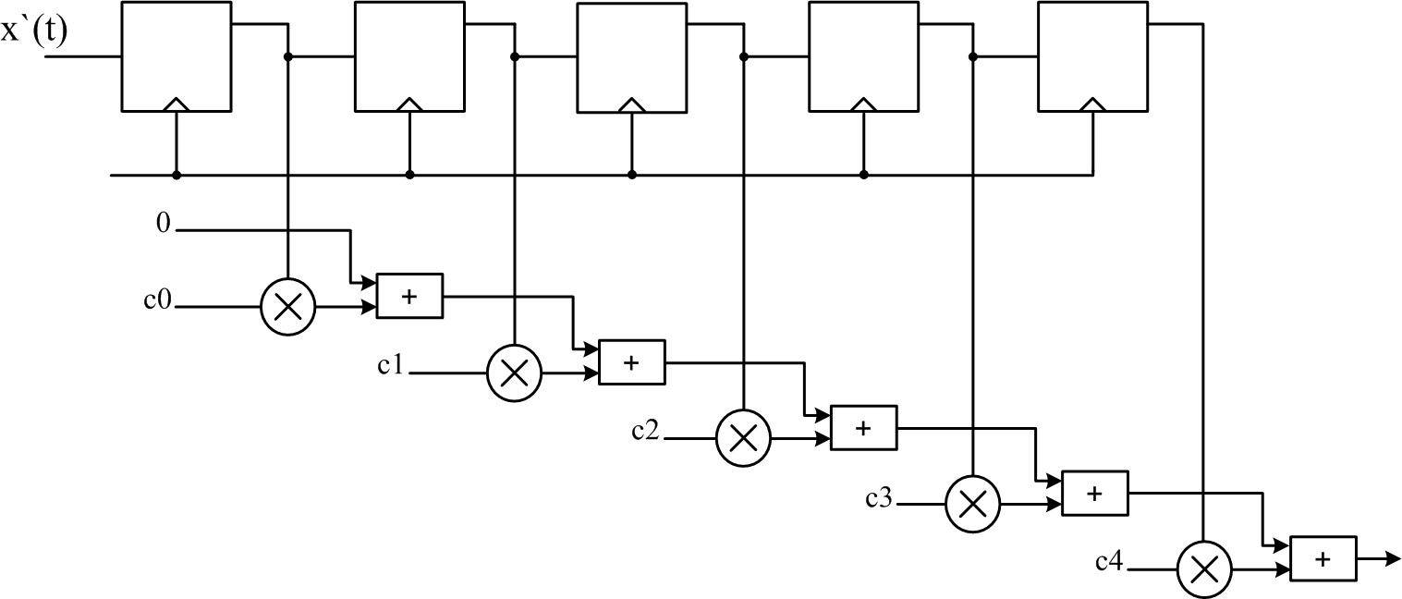

Processor Core FIR Design. The algorithm presented in the above block diagram can be implemented with a processor running the iterative add and multiply procedure. A block diagram of this hardware implementation is shown below.

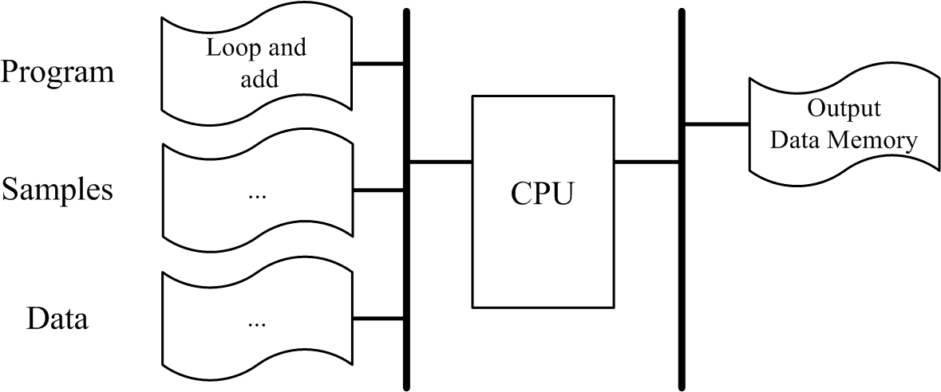
Processor Core for FIR Implementation

The data memory of this implementation has a section for storing coefficients and another section for storing sampled data. We assume that sampled data have been sampled and collected using a valid sampling rate for the input signal.
The program memory of the processor has a program that reads a new sample data performs shifting and five multiply and add operations, one for each coefficient of the filter. With each data read, the program outputs a new data for the circuit response.
Design a processor for the implementation of FIR filters. 1) List instructions necessary for implementing an FIR filter. 2) Show architecture (datapath and bussing) for the implementation of your proposed processor. 3) Write VHDL code for the individual components of your design. 4) List the necessary control signals. 5) Show the controller of your processor. 6) Show the complete wiring of your processor. 7) Write a sample filter program of your processor.

